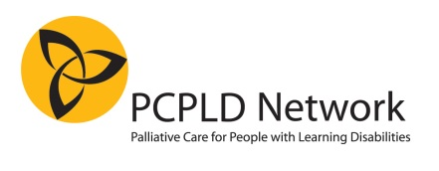
REGISTRATION FORM

PCPLD Network 20th anniversary conference
A showcase for excellence in palliative care provision for people with learning disabilities
13th June 2018, 09.30-16.30 at Friends House, 173 Euston Road, London NW1 2BJ

COST: £150.00
Including lunch and refreshments

PLEASE COMPLETE ALL DETAILS AND SIGN THE BOOKING FORM

Your name

Your job title

Your organisation

Your email address

Dietary or access requirements |  | Are you presenting a poster (see below)
□ Your email address will appear on delegate lists - please tick this box if you DO NOT wish this to appear
PCPLD will not use your data given above for purposes other than the administration of this event.
□ I am paying by BACS transfer to
Account name: PCPLD Network Sort code: 30-91-49 Account No: 02371249
Please quote your name followed by Conference, or CONF
□ I enclose a cheque payable to PCPLD Network
□ I request an invoice to be sent to: Invoices are sent as PDF email files. PCPLD is NOT able to process credit card payments.

Contact person for invoice

Purchase order number

Email address and phone number for invoice If different from above

Signed: Dated:

Please return this form via post or email to:
Anne Garley, 66 Castle Street, Portchester, Fareham, Hants, PO16 9PX. Email: annegarley@gmail.com

CONFIRMATION OF BOOKING will be sent once payment has been received
FINAL INFORMATION will be sent out approximately two weeks before the conference
REFUNDS: 80% refund if cancelled before 31 May 2018. No refunds thereafter. Delegates who are unable to attend are allowed to transfer their place to another person.
POSTERS: Abstracts are invited on any topic relevant to palliative care for people with learning disabilities. Please email your abstract (max 300 words) to info@pcpld.org, and clearly indicate that it is a conference poster abstract.
Abstract deadline: 30 April 2018.
Notification of acceptance/rejection: within 2 weeks of abstract submission. At least 1 author should present the poster in person, and must register for the conference.
One presenter per poster will qualify for a reduced delegate rate of £100.

