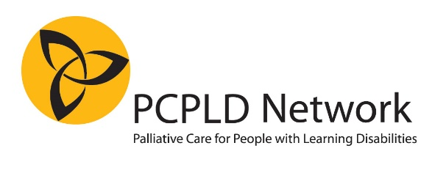

End of life care for people with learning disabilities:
Are we prepared?
21st National Conference of the PCPLD Network

16th September, 09.30-17.00 at Radisson Blu Hotel, Bute Terrace, Cardiff CF10 2FL

CHAIR: Professor Irene Tuffrey-Wijne Professor of Intellectual Disabilities and Palliative Care
Chair of the PCPLD Network

KEYNOTE LECTURE 1: “Making the Mental Capacity Act work for those who most need it”
Baroness Ilora Finlay Professor of Palliative Medicine, Cardiff; Chair of the National Mental Capacity Forum

KEYNOTE LECTURE 2: “With The End In Mind: Making friends with death”
Dr Kathryn Mannix Professor of Palliative Medicine; Author of “With The End In Mind”

Other speakers include:
Dr Caroline Dalton ”Shared end of life decision making with people with learning disabilities in Ireland – an ethnography”
Ms Hanna Noorlandt “Developing a tool for shared decision making with people with learning disabilities in the palliative phase in the Netherlands”
Ms Lilette Denton St Christopher’s Hospice London (winners of Linda McEnhill Award 2018): Developing an outreach programme to support care homes of people with learning disabilities

With a performance by people with learning disabilities from the Misfits Theatre Group

The day also includes: Poster presentations -- Networking opportunities -- Book stand –
Presentation of the Linda McEnhill Award 2020

Cost
£120 early bird (registration before 30 June 2020) and £170 thereafter
£30 concessionary rate for people with learning disabilities
Lunch and refreshments included
Who is it for?
This conference will be of interest to anyone who is involved in supporting people with learning disabilities who are reaching the end of life, and those who are bereaved. That includes families, carers, health and social care staff, service providers and commissioners. People with learning disabilities are also warmly invited to attend. All delegates will receive a certificate of attendance.
POSTERS
Abstracts are invited on any topic relevant to palliative care for people with learning disabilities. Please email your abstract (max 300 words) to info@pcpld.org, and clearly indicate that it is a conference poster abstract.
Abstract deadline: 31 July 2020
Notification of acceptance/rejection: within 2 weeks of abstract submission
At least 1 author should present the poster in person, and must register for the conference. Poster presenters qualify for early-bird rate of £120 even after the early-bird deadline has passed.

EARLY BIRD REGISTRATION FORM
Registration before 30 June 2020
For a Word version of this form, click HERE
Conference: 21st PCPLD Network Conference
Date: 16th September 2020, 09.30-17.00
Venue: Radisson Blu Hotel, Bute Terrace, Cardiff CF10 2FL
Deadline for registration: 31 August 2020

Delegate name:
Email:
Where do you work? (name of organisation/employer):
What is your job/role?
Telephone: (in case we need to contact you, this will NOT be published)
A list of delegate names, job titles and place of work will be available for all conference delegates. We will not share telephone numbers. If you would like your email address to be included on the list, please indicate below
□ Yes, include my email address □ No, do not include my email address

PAYMENT
□ £120.00 early bird payment (registration before 30 June 2020 OR poster presenter)
□ £170.00 registration after 30 June 2020
□ £30.00 concessionary rate (only for people with learning disabilities)

Payable to:
Name: PCPLD Network
Sort code: 30-91-49
Account number: 02371249
□I have paid via Direct Bank Transfer
As a reference, please quote “Conference” followed by your name.
Failure to do so means we may be unable to link your payment to your registration
□I enclose a cheque (payable to “PCPLD Network”) for .....
□please invoice my organisation (please complete all details below. Invoices are normally sent by email.
Name of organisation:
Contact person name:
Email:
Phone number:
Purchase Order number:
Address (optional – only needed if you would like us to post your invoice)

Please return this form via post or email to:
Anne Garley, 66 Castle Street, Portchester, Fareham, Hants, PO16 9PX
Email: annegarley@gmail.com

REFUNDS: 80% refund if cancelled before 31 August 2020. No refunds thereafter. Delegates who are unable to attend are allowed to transfer their place to another person.
□Photographs and videos may be taken at the conference and published on our website, social media and in other formats. If you do NOT wish to be recognisable in these, please tick the box.

