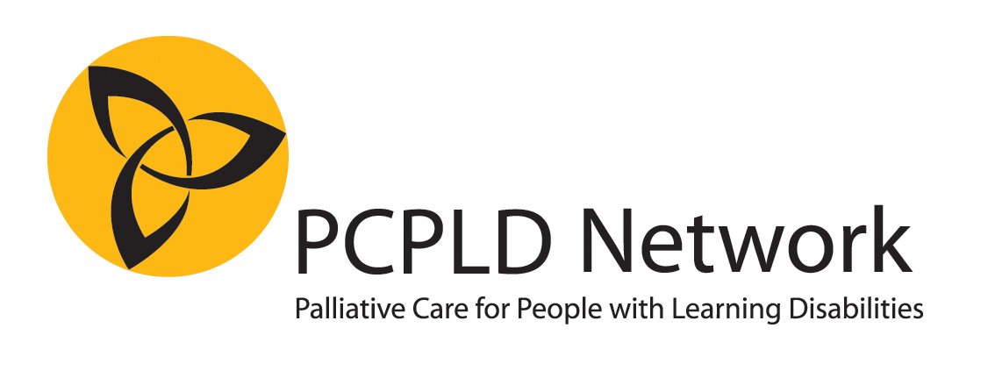
Nomination for the Linda McEnhill Award 2020

Category B
Outstanding end of life support of an individual
NOMINEE
Title / Name of individual, team or organissation
Address

Telephone number
E mail

NOMINATOR (NB it is possible to nominate yourself, or your own team)
Name
Address

Telephone number
Email

Relationship to nominee
Please complete a statement of up to 1,500 words, explaining why you think this person/team should be given the award.
It is recommended (but not obligatory) to use the guiding questions on the next page. You may find that not all the questions are relevant, or you may want to tell us something different.
Please make sure that you do not include any information that might identify particular people with learning disabilities or family members. Use single initials only. Do NOT include any photographs of the person.
Please include or attach an accessible version of your nomination.
Do not submit any additional documentation. Any attachments other than the statement will NOT be seen or assessed by the judges.
If you have additional documents or information that you think would be helpful to the judges, please let us know what it is. We may ask you to send it to us at a later stage.
About the person: Describe the person with learning disabilities (it is helpful for us if you can “paint a picture” of the person and the life they lived when they were well)

The person’s illness: Tell us something about how the illness started, the diagnosis, early treatments, and how the illness progressed.

Who was involved? At the time of diagnosis, and later, as the illness progressed (you may prefer to tell us about this whilst describing the illness itself – but make sure we know which professionals, carers, family members, friends etc where involved)

Care Planning: Tell us about about the person’s physical, psychosocial and spiritual needs, and how these were addressed

The end of life: Tell us about the person’s dying and death, their funeral, or anything else you wish to say about the time around and immediately after the death.

After the death: What was the person’s legacy? How do those who supported the person look back on the experience? What have they learned?

Please send the completed form and any queries to info@pcpld.org

